

p. swethanagsri

SURABHI ANUSHKA

2520090168
CSIT
CO5

Case Study Topic: Incident Priority Sorting using Counting Sort Algorithm
Work Done Summary:
In this case study, we developed a Java-based sorting system for incident records in the CivicEye – Smart City Incident Monitoring
& Response System. The system sorts incident reports using a composite key consisting of incident priority level and incident ID. Since
the range of priority levels is small, the Counting Sort algorithm was chosen for efficient sorting.
Using Java, we implemented stable Counting Sort to first sort incidents by incident ID and then by priority level. This approach
ensures that incidents are arranged in proper order while maintaining stability.
The Counting Sort approach improves performance for large smart city incident datasets and provides efficient incident management, emergency response planning, and analytical reporting.

Implementation Details:
- Created an Incident class in Java to store Incident ID and Priority Level.
- Stored all incident records in an array.
- Applied stable Counting Sort on Incident ID.
- Applied stable Counting Sort on Priority Level.
- Used reverse traversal while placing elements to preserve stability.
- Displayed sorted incident records in priority order.
- Verified correctness of sorting results.

Output:
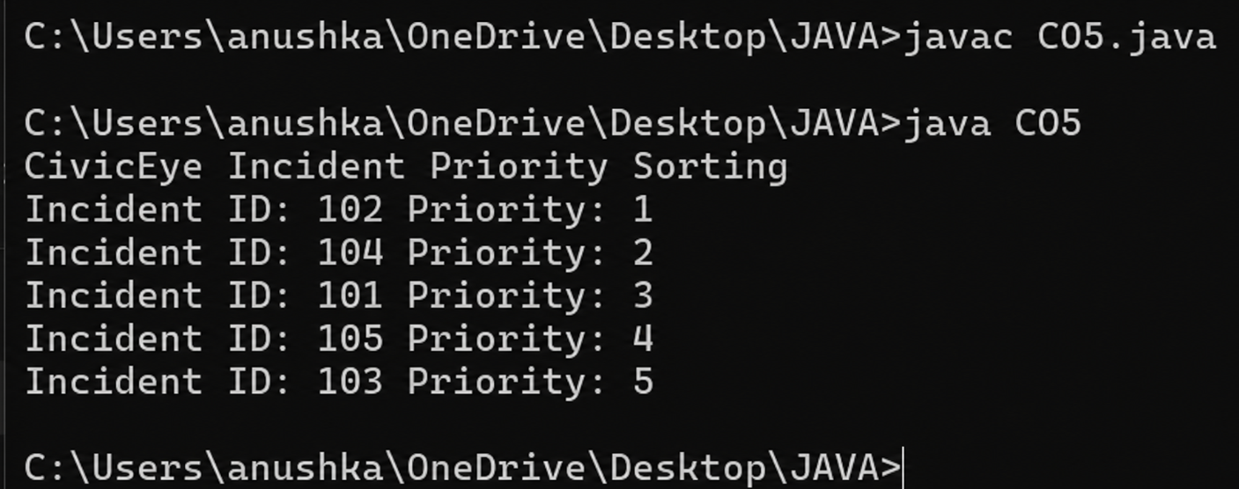

The Counting Sort algorithm successfully sorted incident records based on their priority levels. The CivicEye system can efficiently organize emergency incidents, ensuring faster response and better resource allocation
for city management.
Github link:

